**FINAL LABORATORY ACTIVITY #1**

**Cooperative On-Line Membership Registration**

Group No. 4

Leader: Renz Ivan Lope

Members:

1. Angeline Marie Labaniego
2. Baron James Frias
3. Charina Jimenez
4. Richelle Funa

Page 1: Registration Form *(blank form)*

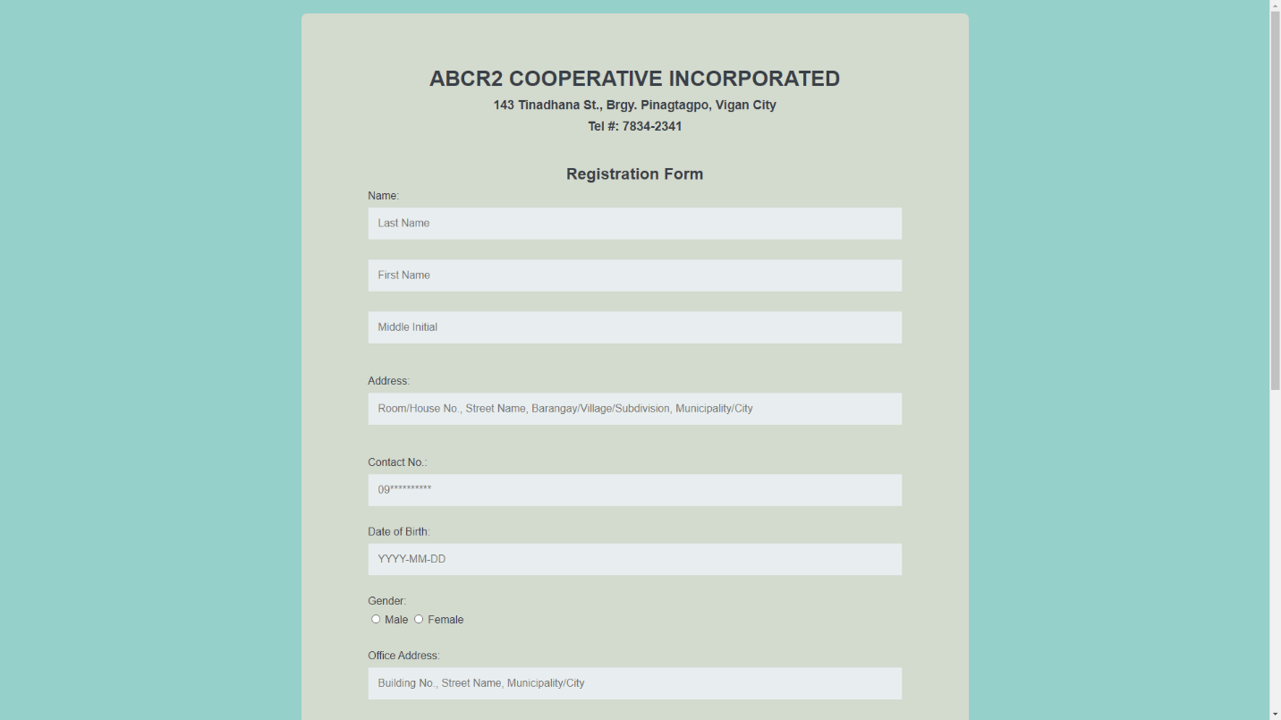

*

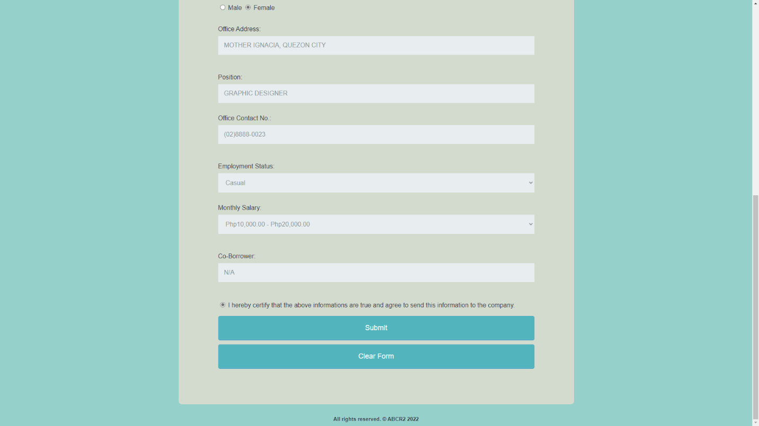

Page 2: Member Information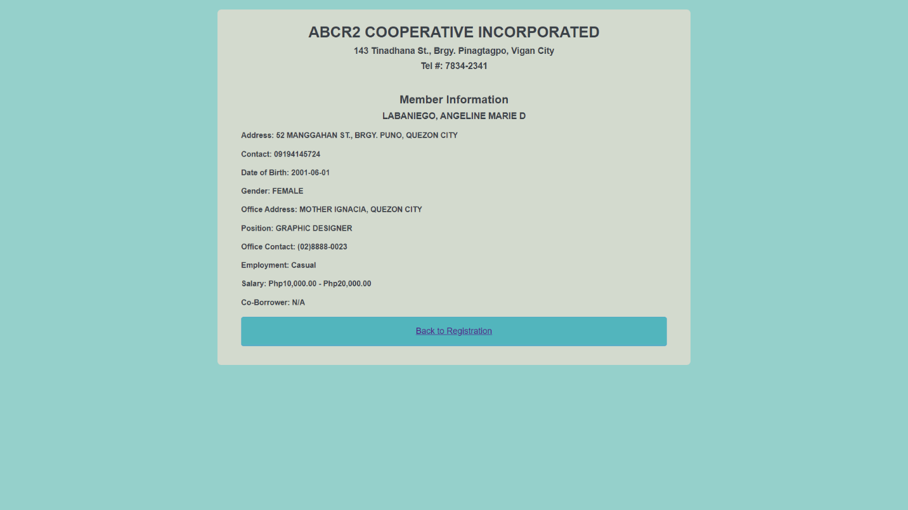

Source Codes:

*For Registration…*

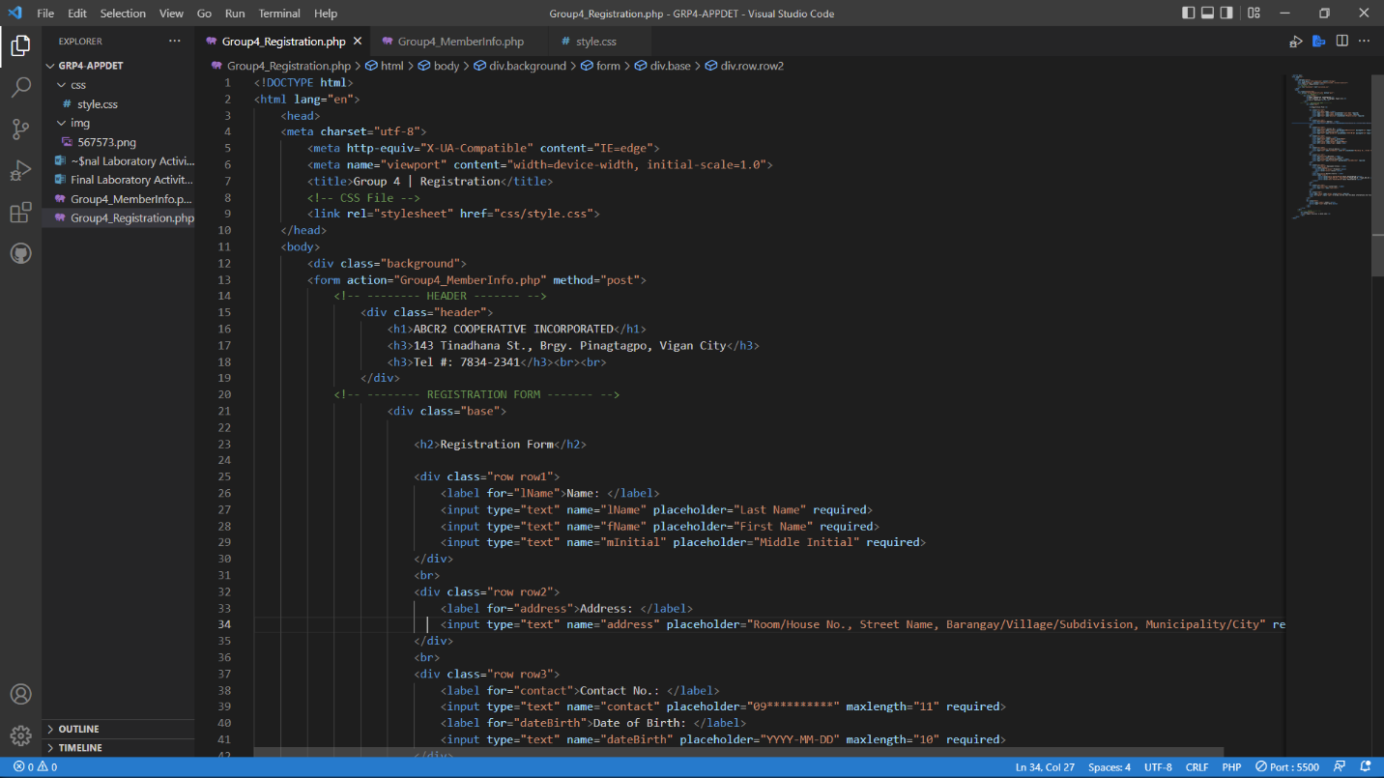

In creating the registration for, we’ll start with typing the <!DOCTYPE html> then the html lang=”en”. It means that the html language attribute is english. Then type the meta tags. Meta tags give little snippets of information to assist search engines and browsers understand more about the intent of your content and how you want it displayed.

**The X-UA-Compatible IE=Edge meta tag**

1. html headers are used to communicate additional information from the client and server to the visitor’s browser.
2. http-equiv – this creates an html header that contains information for the browser
3. X-UA-Compatible tells the browser, if it is Internet Explorer, to render the web page for a particular version of Internet Explorer.
4. The content= sets the value or version of Internet Explorer that the page should be rendered for
5. IE=edge sets this value so IE (Internet Explorer) renders the page for the latest version available for the browser being used which is currently Microsoft Edge

**X–UA–Compatible** is a document mode meta tag that allows web designers to specify for which version of Internet Explorer the page should be rendered as.

Then the title that will reflect in the tab is named as “Group 4 | Registration”. Then we also linked our stylesheet to the php file of the registration so that the design will reflect on the page.

Then the <form action="Group4_MemberInfo.php" method="post"> is for the Member Information page to show after the users submitted their information.

We’ve added some comments in able for us to easily identify the tags for each part of the page. So we have the CCS file, header, registration form then the footer.

In creating the registration form, the tags that were used are div and br for section and breaks, then label for the labels of each text box, and input for the text box. Each text box has a placeholder, so that the user will have a guide on how they should input the information. Then for the gender section, we used a radio button instead of text bow. Then for employment status, we used an option tag for the dropdown feature.

We include a statement in which a user will agree that the inputted information of the user are true and had agreed to send the information to the company. Then we made two responsive buttons: one is for the submission of form and one is for the clearing of the inputed information. And then we have the footer.

*For Member Information…*

In the Member Information page, same goes with the Registration page, we’ll start with typing the <!DOCTYPE html> then the html lang=”en”. Then the following meta tags and the linking of the stylesheet. Then the content of the header in this page is same as the header in the Registration page.

Then we used the PHP syntax and tags for the showing of the inputted information of the user. We separated the syntax variables from the echo statement, for easy recognition of the variables and values.

Each variables are intended for each needed information. $lname for the Last Name, $fname for the First Name, $minitial for the Middle Initial, $address for the Address, $contact for the Contact Number, $dateBirth for the Date of Birth, $gender for the Gender, $ofcAddress for the Office Address, $position for the Position, $ofcContact for the Contact Number of the Office, $empStat for the Employment Status, $salary for the Salary and $coborrower for the Co-Borrower.

Remember that all variables in PHP start with a $ (dollar) sign followed by the name of the variable. A valid variable name starts with a letter (A-Z, a-z) or underscore (_), followed by any number of letters, numbers, or underscores. If a variable name is more than one word, it can be separated with an underscore (for example $employee_code instead of $employeecode). '$' is a special variable that can not be assigned. Also, all variables are case-sensitive. So make sure, to double check the inputted variable or else the value will not reflect, and might show an error to your code.

For the printing of the information, we used the echo in able to show the inputted data information in the page. We can display string, variables with echo function, additionally, we can embedded html commands into echo command. Here we have attached html header element into echo.

Then we’ve created button in able for the user to redirect again to the registration form.

*

We’ve separated the stylesheet and the php files, so that it would easier for us to identify and edit the css if it has an error in it. The asterisk shows the universal design wherein it whatever we put in it, it will reflect in both pages. All the styles from the background, to the fonts, sizes, borders, text boxes and buttons are all here in the stylesheet. Also, for the pages to be responsive if used in any devices, we used media screen.